L. D. College of Engineering
Internal hackathon for SIH - 2023
Date:22/09/2023
L.D. College of Engineering, Ahmedabad had organized an institute level internal hackathon to shortlist the teams to be registered for Smart India Hackathon-2023 on 22/09/2023 at Annexe bulding of the institute.
Total 105 teams (606 students, 436 male and 170 female) of students have participated in this event. As per the guidelines of Smart India Hackathon – 2023, and to encourage female participation in innovative projects, each team consists of at least one female student as member. The participants of the institute have worked on 78 different problems put forward by various ministries of Government of India as well as problems from various PSUs. Out of them, 54 software problems and 24 problems of hardware categories were chosen by the participants to work upon. To evaluate and shortlist the teams, 11 judges having industrial/academic experience in various fields were invited.
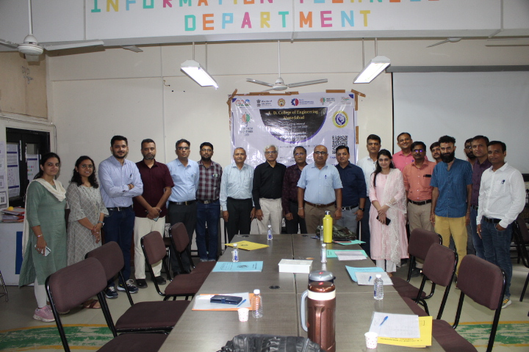
The registration process was started at 10:00 AM on September 22, 2023 at Annexe building. Total 106 teams with 606 students reported for the event.
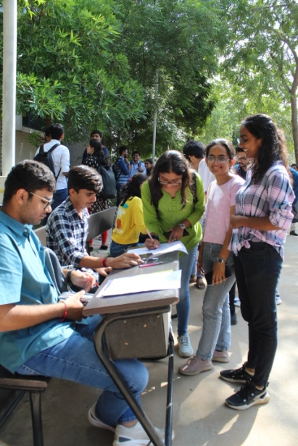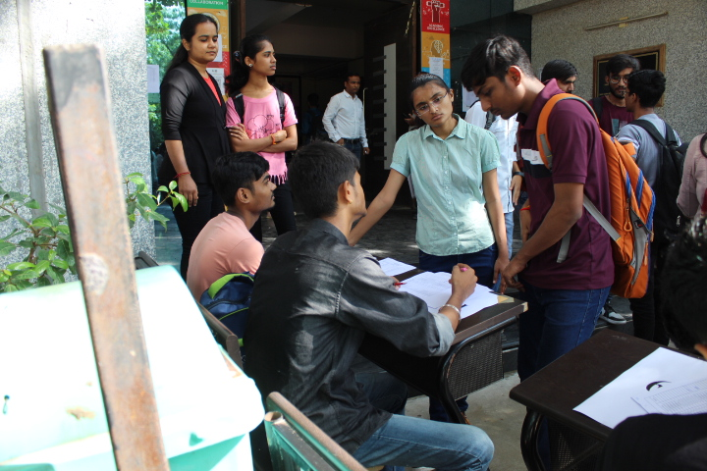
After registration, students were allocated appropriate space with necessary logistic support to work on the problem. The necessary resources were provided by institute to respective teams and subsequently students started their project setup accordingly. From around 10:30 AM to 1:00 PM, participants worked on the solving the defined problems and made themselves ready for presentation and demonstration.
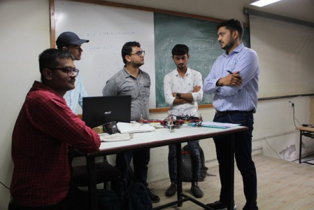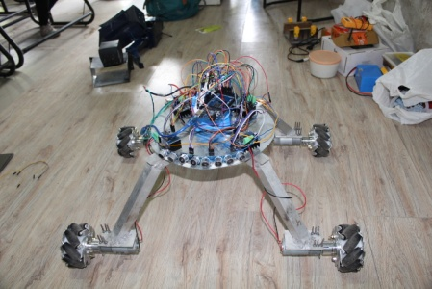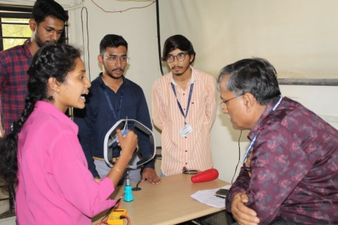
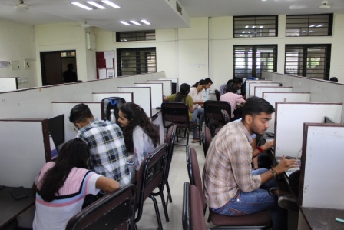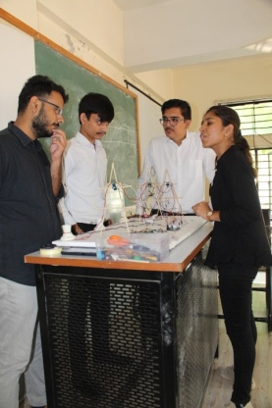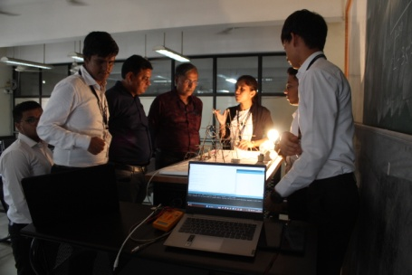
From 1:00 pm to 1:30 PM, lunch break for participants was arranged with delightful food.The participants enjoyed the food.
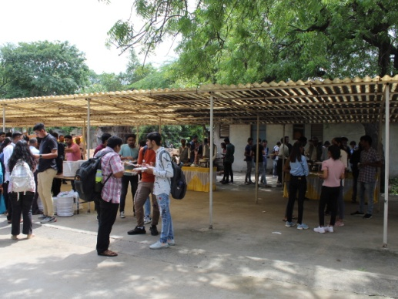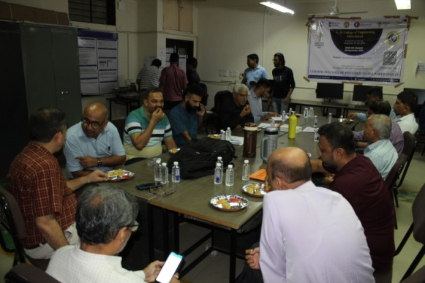
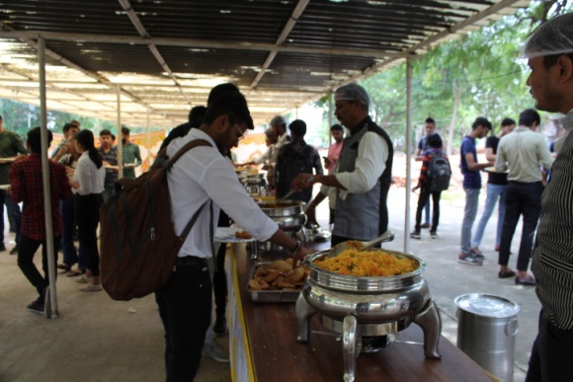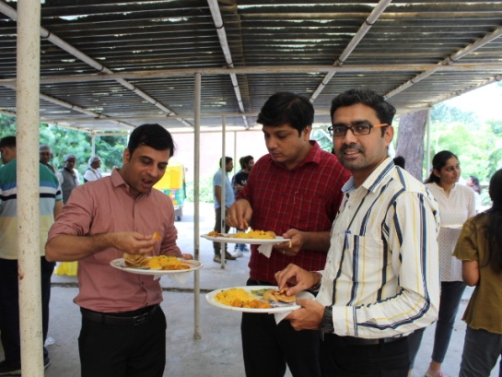
After lunch, the jury members visited all the participating teams for evaluation purpose. Total 11 juries were invited and they evaluated the teams based on following uniform criteria:
- Clarity and details in the prescribed format(Problem Understanding)
- Novelty of the idea
- Complexity
- Feasibility
- Sustainability
- Practicability
- Scale of Impact
- Quality of Solution & user experience
- Potential for future work progression
- Teamwork and Presentation

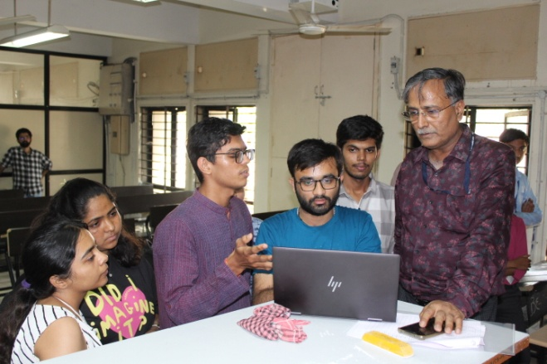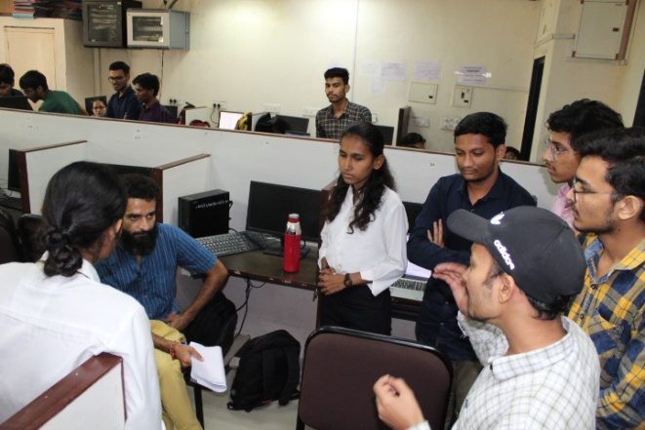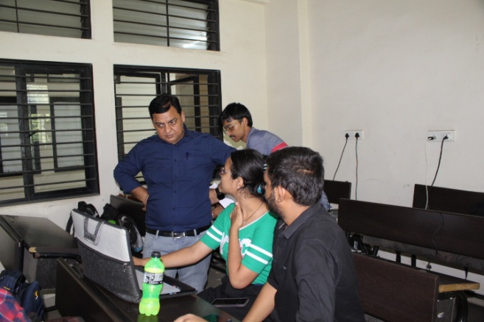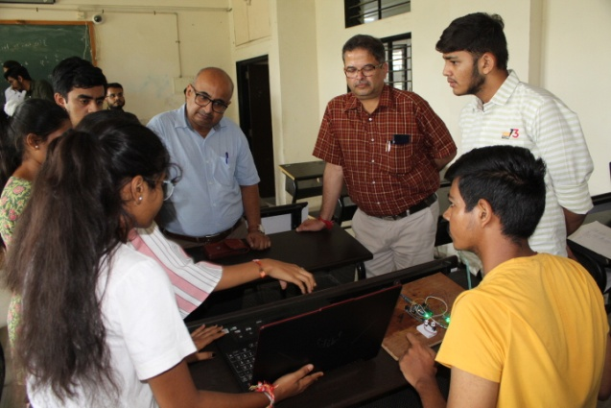
The list of invited jury members is as under:
 | Judges name | Designation | Department | Organization
1 | Vaseem Lahori | Vice President- | Software | Technology & Solutions
2 | Hardeep H Pathak | Founder | Software | Writopedia
3 | Bharat Thakkar | President | Business Mentor | Federation of Entreprenerus
4 | Dr. Suryakant Gupta | Scientific Officer | IPR | IPR Gandhinagar
5 | M S Dave | Sr Lecturer | EC | G P Ahmedabad
6 | N R Merchant | SR Lecturer | EC | GGP Ahmedabad
7 | Gaurav Asari | Assistant Professor | EC | VGEC Chandkheda
8 | Dr Shriji V Gandhi | Lecturer | IC | GP Ahmedabad
9 | Ms.Zankhana D Mehta | Lecturer | IC | GP Ahmedabad
10 | Saifee M Vohra | Lecturer | IT | GP Ahmedabad
11 | Prof. Alpesh thakar | lecturer | computer | GP Ahmedabad

At the end of rigorous evaluation by judges, total 30 winning teams and 5 waitlisted teams are decided to be registered for Smart India Hackathon – 2023 from L. D. College of Engineering. These winning teams will now be provided mentorship from experts from industries and academia and will be nurtured for SIH-2023 as well as other competitions.
Following teams are the winners shortlisted from the event
Sr. No. | Team | PS Number | Team Leader Name
1 | S5 | SIH1319 | KANANI AYUSH MAHESHBHAI
2 | S52 | SIH1287 | Patel Divyakumar Bharatbhai
3 | H31 | SIH1439 | Kirtan Patel  9586043272
4 | H33 | SIH1361 | Swayam Chauhan 9724729058
5 | S61 | SIH1450 | Shubham Patel
6 | H30 | SIH1478 | Sanjay Soni  7043464491
7 | H34 | SIH1442 | jaydeep prajapati 9427489543
8 | S47 | SIH1286 | Manan Sanjaybhai Shah
9 | S56 | SIH1460 | Shubham Pandit
10 | S68 | SIH1440 | Nihal Rajpal
11 | H08 | SIH1404 | Yash Patil  8141134645
12 | S22 | SIH1309 | Nayak Sahil Dharmendrabhai
13 | S45 | SIH1346 | Shirsat Vivek Ashokbhai
14 | S64 | SIH1446 | Shyam kakkad
15 | H10 | SIH1361 | Nithyaashree P. Chettiar 7990090140
16 | S26 | SIH1356 | GANDHI KARAN MANUBHAI
17 | S11 | SIH1317 | SINH SHREYANSHU SATYANARAYANSINH
18 | H09 | SIH1406 | Harsh Rajput 9265735936
19 | S25 | SIH1286 | RAHUL SHAH
20 | H23 | SIH1475 | Suthar Jay Anilkumar 9106047233
21 | H25 | SIH1327 | Jinansh Rajendrakumar Chauhan 8401928401
22 | H26 | SIH1470 | Suthar Jay Anilkumar 9106047233
23 | S19 | SIH1363 | Harsh Yadav
24 | S30 | SIH1417 | Karan Hetalbhai Shah
25 | S42 | SIH1343 | Justin George
26 | H02 | SIH1499 | Dhruvkumar Patel 8347486275
27 | S23 | SIH1440 | Patel Diya Vinodbhai
28 | S1 | SIH1464 | Manav Shah
29 | S2 | SIH1468 | Smit Upendrabhai Patel
30 | S43 | SIH1397 | Yash Patel

Following teams are considered to be waitlisted:
1 | H15 | SIH1448 | Siddharth Rathod 7202979850
2 | S15 | SIH1500 | Makwana Chirag Rameshbhai
3 | S27 | SIH1285 | Ansh Shrivastav
4 | S35 | SIH1486 | KRISHAL DANKHARA
5 | S39 | SIH1498 | Apoorva .S. Mehta

The promotion of the event was also carried out on various social media platforms. The links of such social media promotion are mentioned below:
https://www.facebook.com/ldce.ac.in
https://www.instagram.com/ldceofficial/
https://in.linkedin.com/school/l.d-college-of-engineering---ahmedabad/
At the end, there was a valedictory session where judges were facilitated by awarding certificates. Event ended with vote of thanks by Committee chair person.
